|  |
| --- |
|  |
| Kitting |



Project name:

KITTING for AX2012 R3

Prepared by:

Kurt Hatlevik

Contributors:

Table of Contents

1 Introduction 3

2 Prerequisites 3

3 General information 3

3.1 Kitting and sales order 3

3.1.1 Explosion 3

3.1.2 Price and discount calculations 4

3.1.3 Inventory transactions to kits 5

4 Setting up Kitting 6

4.1.1 The Kitting form letter setup form 6

5 Kitting FAQ 8

6 Quick product seach and inquery 10

6.1 Smart item lookup 10

6.2 Product inquery 13

# Introduction

Kitting is a great alternative for companies that are not equipped with finished goods warehouse facilities or cannot afford the capital expenditure of setting up a finished goods warehousing facility.

# Prerequisites

Before installing KIT for Dynamics AX 2012 R3, please ensure that the system meets or exceeds the following Dynamics AX builds.

|  |  |
| --- | --- |
|  | Application build |
| DAX 2012 R3 | CU8/CU9 |

# General information

## Kitting and sales order

One of the requirements is to show the kitting structure in the sales order form in Dynamics AX. Kitting stipulates that there is a hierarchy of items, where only the bottom level is real items that are purchased, stocked and priced, while the upper levels are phantom BOM items. When a customer orders a product, the customer only need to relate to the uppermost BOM-level, while the warehouse workers are picking the actual contents of the kit.

### Explosion

Explosion of a phantom BOM items on a sales order is built into the order line processing procedure, the procedure that takes place every time a sales line is inserted, deleted or updated.

The parameter field Phantom that exists on the item table. This parameter defines if a BOM item is exploded on the sales line. Explosion of BOM item is performed on all BOM levels and all the phantom BOM levels create sales lines marked as a kit, while real items create normal sales lines. The relation between levels for the Kit sales lines is established via a new reference field related to the sales line. When using the sales order screen, the order looks just like the normal sales order screen:

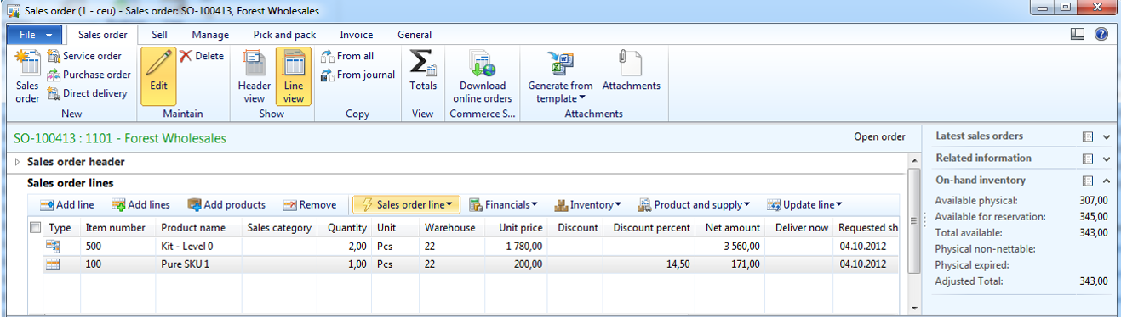

By clicking on the “Show/Hide kit lines”, all lines are shown inside each kit:

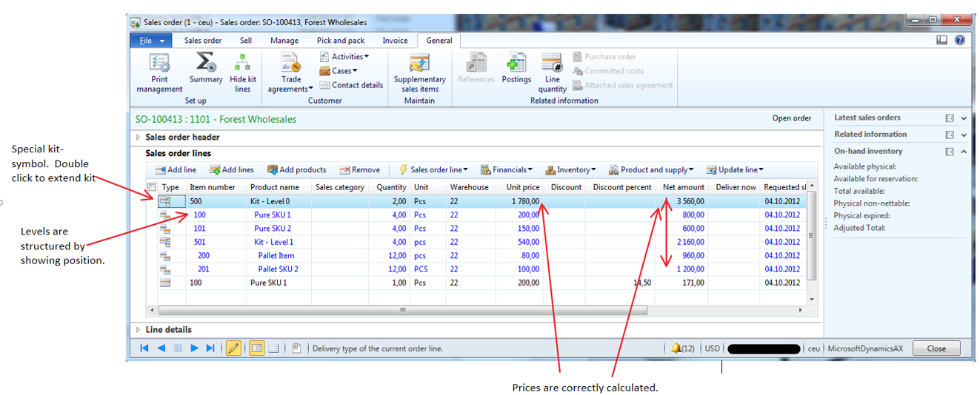

The bottom-level sales lines (real stocked items) should be editable only in terms of quantity, unit price, line discount amount and multiline discount amount, the rest: delivery dates, etc. is derived from the uppermost line.

The structure of BOM cannot be manually adjusted: sales lines that are sub levels of the top phantom BOM cannot be manually added, but unwanted lines can be deleted.

### Price and discount calculations

The pricing of kits can be done in two ways. The pricing behavior is defined on the product under the engineering – Kit price setting :

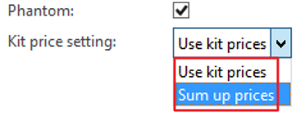

Use kit prices means that the system will only use the prices defined on the kit. There are no sum ups. The prices are fetched like any other item. The kitting lines will have a zero sales price.

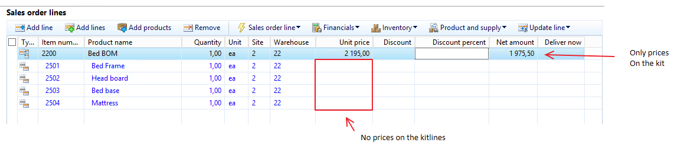

When the kit is a SUM-UP kit, meaning that prices and discount are set on the lowest level of BOM. The price on the upper level is always the sum of the sub lines. The prices are fetched on the kit lines.

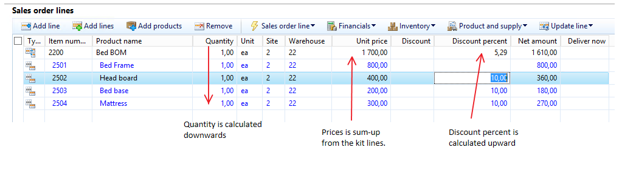

|  |  |
| --- | --- |
| Field | Calculation direction |
| Sales quantity | Calculated downwards |
| Unit price | Calculated upwards |
| Discount amounts | Calculated upwards |
| Discount percent’s | Calculated upwards |
| Line amounts | Calculated upwards |

### Inventory transactions to kits

The kits do not have inventory transactions. The reason for this is that kits are “virtual items” that do not need a physical picking. It is the sub-components that are picked. Kits are still being packing slip updated and printed on the invoice. But still it is possible to see the order process flow of kits, since this can be calculated on the basis of the kit lines. The line quantity form will therefore still give meaning as shown here.

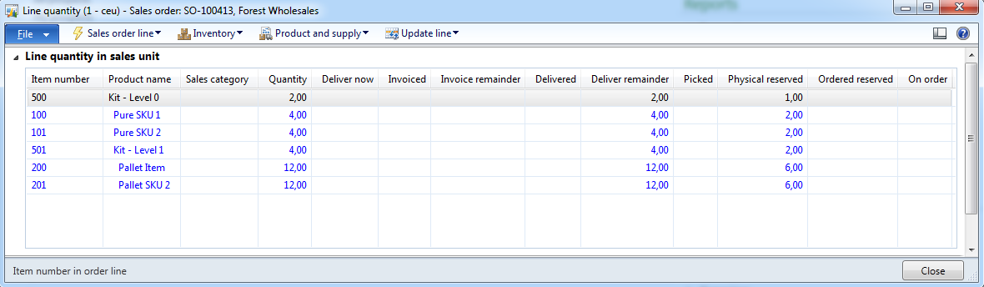

# Setting up Kitting

This section describes how all the Kitting related tables are related to setting up Kitting and how they influence the way Kitting is processed.

### The Kitting form letter setup form

The display of the kitting structure can be shown per item and customer on confirmation, packing slip and invoice. To handle this, a new form Kitting form letter setup is available. This form is following the standard “Table, Group, All” Microsoft Dynamics AX pattern. Here the user can specify if the kitting structure is printed on confirmation, packing slip and invoice for a particular customer.

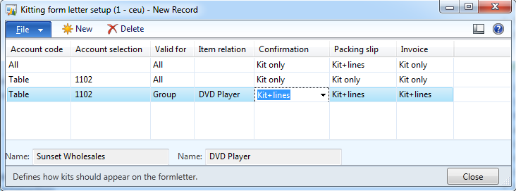

The form is available under Sales and marketing🡪Common🡪Kitting🡪Kitting form letter setup.

If the *Show kitting structure* is enabled, the form letter will show the kitting structure as follows:

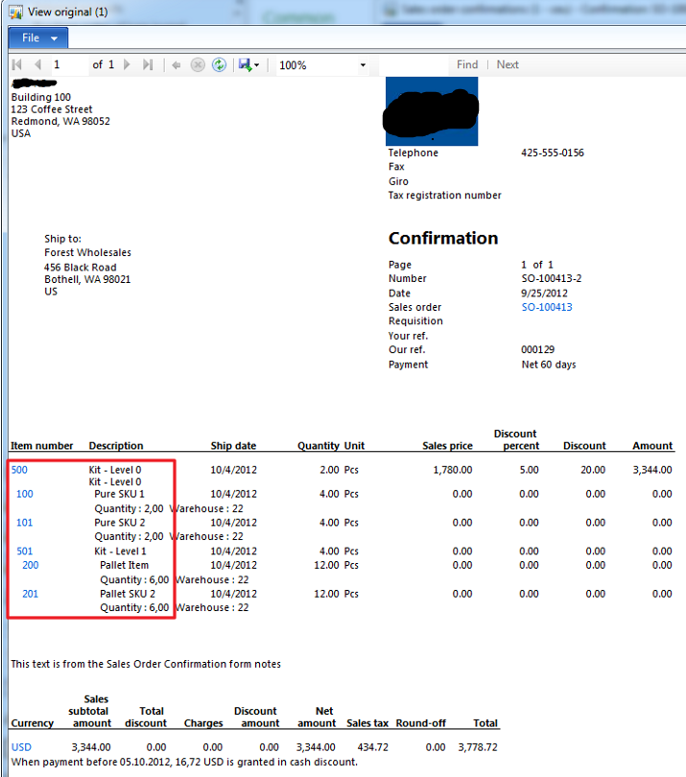

# Kitting FAQ

This sections covers information related to Assembly and Kitting, and is described as a FAQ.

|  |  |
| --- | --- |
| Question | Answer |
| I have a kitting line, but I don’t have any inventory transactions associated to it. Why? | All exploded kitting lines do not have any inventory transactions. It is only the real items that have inventory transactions. All statuses on the kit are based on the containing lines. |
| Why can’t I change sales price on a kit. | Price on a kit is based on the prices on each included item. To change the price of a kit, you need to change the prices on the included items. |
| How do I set up an item as a kit? | A kit needs to be an approved BOM. The flags ‘Phantom’ also need to be enabled. (*References* tab page in the **Item details** form)    Also select the Kit price setting, og how the pricing should happen. |
| How do discounts work on kits? | In AX you have 2 types of discounts. Discount amount and percent. On Sum up kits, percent and discount amounts need to be set on the separate kit lines, while on “use kit prices”-kits the prices and discounts can be set on the kit itself. |
| How do taxes work with kits? | Taxes are calculated on the kit lines in a SUM-UP kit, and not on the kit itself. The taxes and VAT is therefore calculated like standard AX. “Use Kit prices”-kits will behave like any other item. |
| I see on the confirmation and invoice that only the kit contains the sales value, and the lines are zero. | Yes. This is how kitting works. The sales value and prices are placed on the kits and not on the kit lines. This is also the perception of the customer when he receives the form letter. |
| Can I manually add and remove kit lines? | Kit lines **cannot** be manually added, but they **can** be manually removed The reason for this is that kitting is supported in a multilevel structure. |
| How can I see the kit-lines on my sales order? | You can see the kit lines by clicking on the button *Show/Hide kit lines* on the sales order form, or double click on the  symbol on the lines |
| How can I take out statistics on sale of a kit? | The customer invoice will contain the information required. Therefore use information from here when creating additional statistics/reporting. |
| I see I get a total available, picked, delivered and invoiced on kits. How is this possible? | The total available is calculated on the basis of the kitting lines. The most restricting kit line will decide the total available on the kit-header. |
| Can I part deliver a kit? | Yes, by using the deliver now column, and then starting the picking posting. But it is only possible to part deliver whole kits. You should not part deliver sub-items in the kit. |
| How is returns and credit notes handled for kits ? | Since kits are items that do not have inventory transactions, all returns must be done on the kit-lines. When creating a return on kitting items, it will only be the kit-lines you can take a return on. |

# Quick product seach and inquery

Included with the kitting solution, there are some extensions that makes it easier to find products and information.

## Smart item lookup

I Dynamics AX 2012 and Microsoft SQL has very powerfull features for searching , and the kitting solution is extended with a small generic tool for finding items and products.

Suppose a user wishes to find an item, and it does not know its item number but knows few word of description and also has a small information about class, default supplier, location etc……

He can enter this info and at very next moment he would see the list displaying all the items having the various values similar to information he just entered and then he can select the required item out of it easily.

In standard AX 2012 the item lookup looks like this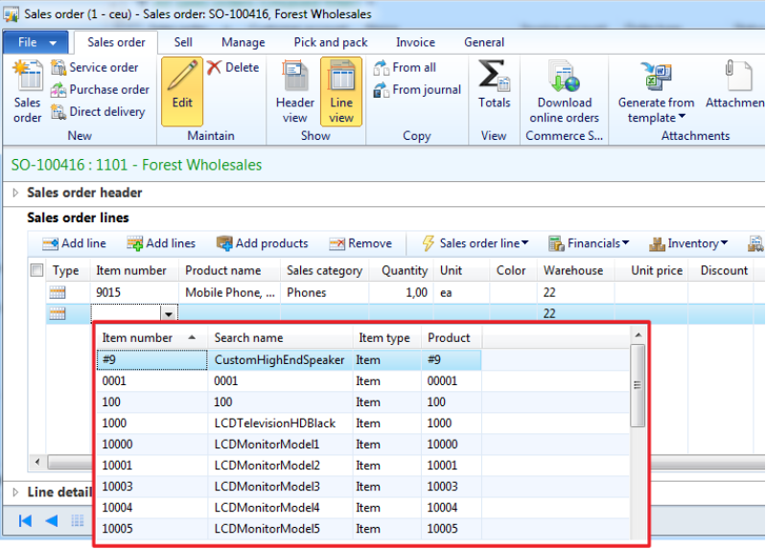:

Since the lookup is attached to the itemId extended data types, this works everywhere you 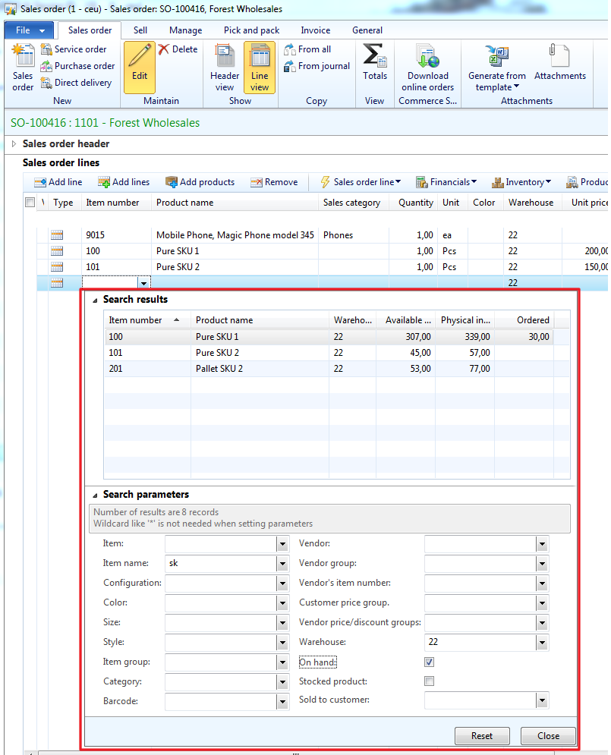have items.

The lookup is a fast tab, where the upper grid shows the query results, and the lower grid shows search parametes.

If “on hand” is checked it will also show current onhand values fetched from a database view. So you can sort and filter on the onhand values.

In the lookup form the user can fill inn filter criteria, like item name, colors, barcode, 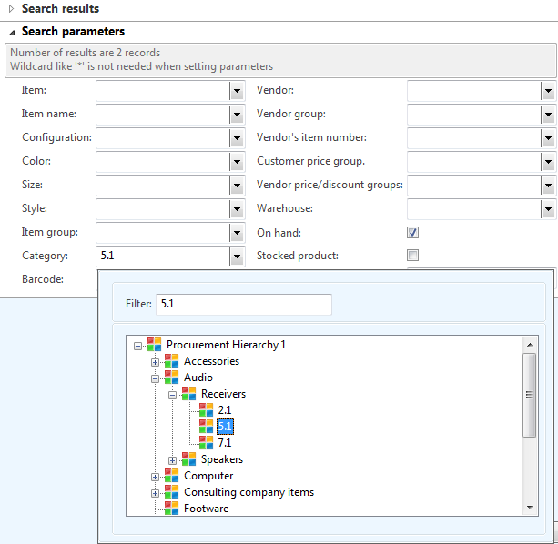vendors/groups etc. The lookup can even use the product categories like this :

All filters work “side-by-side” and together.  So I can ask for products like “***Find a green phone we have on stock at warehouse 22***”.

So to accomplish this, a lot ot outerjoins has been implemented, that is dynamically filtering the lookup. Changing a parameter, and the result grid also changes.

## Product inquery

Product inquery is all about combining commercial information into a single easy to use screen.

It all starts with the following screen: 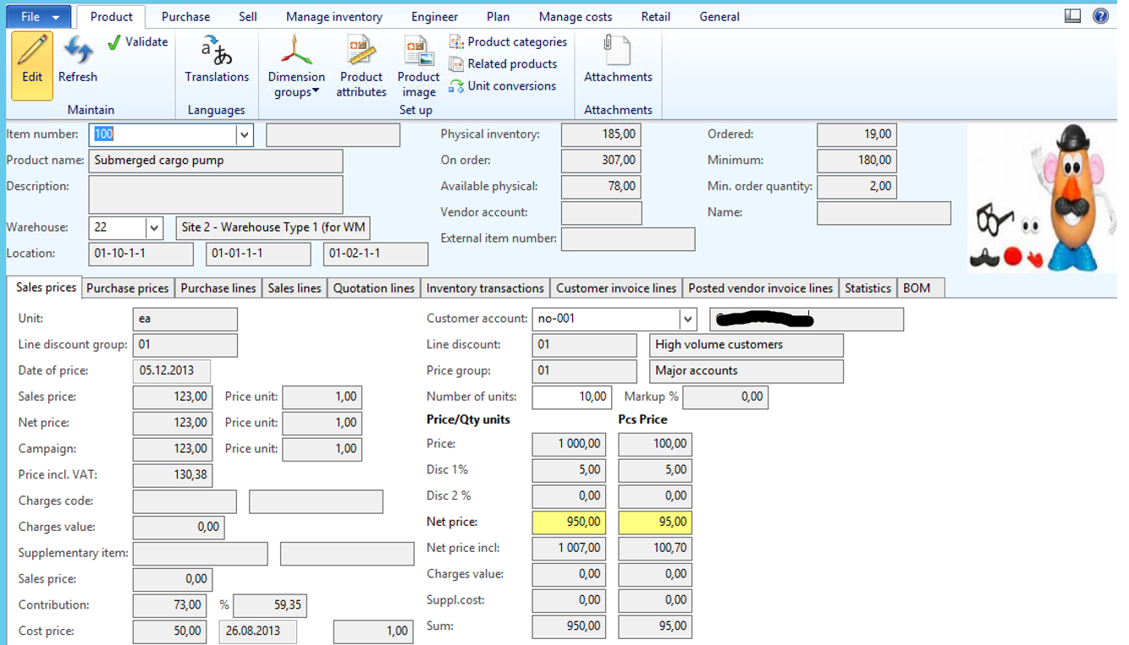

The user may type inn a item number, and the user will get some key information, like name description etc. But also some information like on-hand, vendor, external item ID, most common locations and picture. 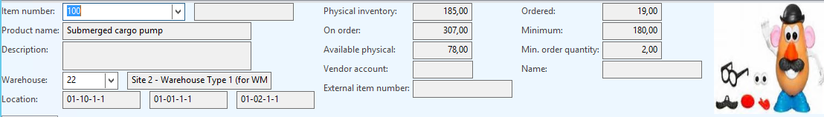

The first screens will show information like current prices with/without VAT and campain prices.

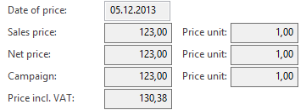

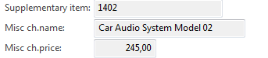Also any supplementary items is fetched:

The next field is the contribution margin in percent and cost price, date and price unit:



In the “customer section”, it is possible to select a spesific customer, to see the actual prices, and also to see the prices based on a defined quantity. The algorithms here is exactly the same as keying in this in a sales order, but this is easier to use.

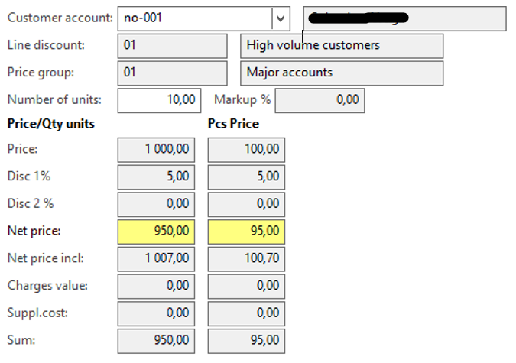

The two columns are then showing prices per unit and also based on the total quantity.

In the tab “purchase prices” the user can see current valid purchase prices. Prices that are not valid is not shown. 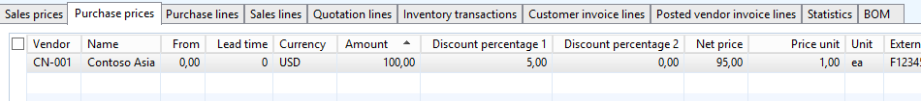

On the tab purchase lines we see only the **open** purchase lines, marking, and confirmed delivery dates. Also see if any of the lines has been registered already.

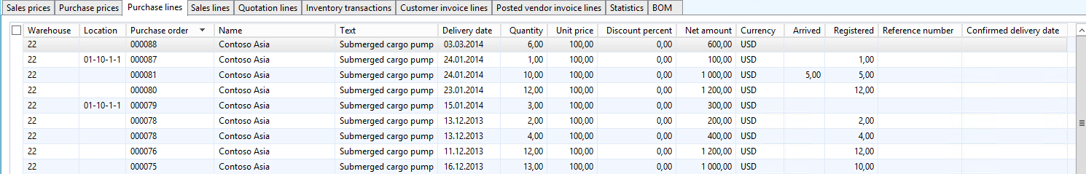

The Sales lines shows **open** sales lines. The inventory transactions, shows ONLY transactions that has affected the physical on hand. Meaning Sold, deduced, picked, purchased, received and registered transactions for the current warehouse

Customer invoice lines, will show all commercial transactions, related to the item. The user can also quicly see previouse dicounts given: 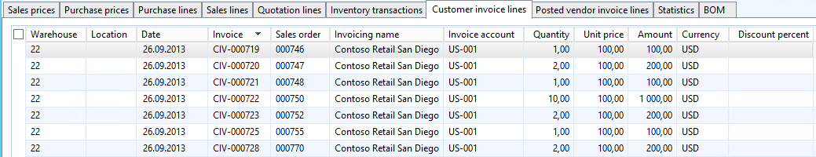

The Posted vendor invoice lines, shows the following: 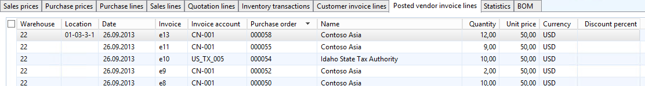

The statistics, will show statistics per month:

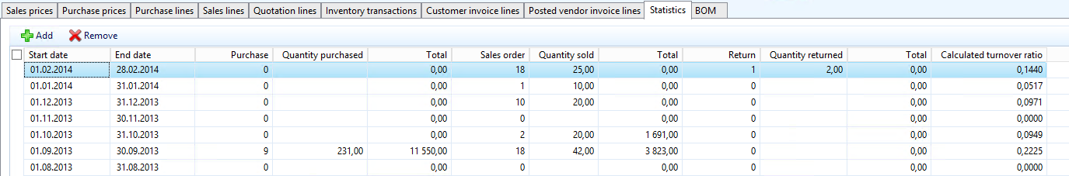

If wanted, the user can them self also key in the start and end date to get statistics on other intervals. The turnover ratio is also calculated.

For BOM/Kits we also have the following: 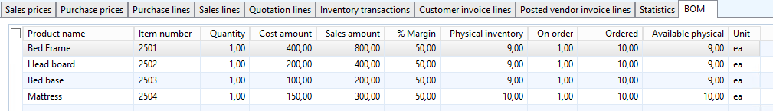

The product inquery have also the “Grid view” to get a very fast overview: 